Howard University Residential Pre-College STEM Program for Engineering Systems Center for Energy System and Controls (CESaC)
College of Engineering, Architecture (CEA)
Howard University, Washington, DC
The PCES Outreach Program is an outgrowth of the Energy Expert Systems Institute (EESI) program. The success of the five-week EESI summer outreach program, offered by CESaC at Howard University, led to several women and minority students considering ECE as a viable college major. The program was a huge success; however, it was abandoned over the last five years with no other program, at Howard University or the surrounding area, to replace it. As a result, underrepresented youth are neither equipped nor developed to handle the grand challenges of the technological revolution in energy such as smart grid; in addition, enrollment in Science, Technology, Engineering and Mathematics (STEM) fields among women and minorities has declined while technological challenges in smart grid, Renewable Energy Resources (RER), nanotechnology and wireless communication revolution. In efforts to increase the number of underrepresented students acquiring degrees in STEM fields, the team at CESaC has devoted their time to developing PCES.

Electrical engineering consists of several specialization areas such as: Communications Theory, Signal Processing, Microprocessor, Digital Systems, Microwave and Antenna Applications, Power and Energy Systems. Electrical and Computer Engineers are involved in a wide array of industries from the design of cellular technology, to the development of the information highway technology, the creation of smart materials such as conductors and microchips for the computer, and to the control and delivery of Electrical Energy for homes, offices and even space stations.

Students having strong backgrounds in Mathematics, Science and English and above all, an interest in the field of Electrical and Computer Engineering are selected to attend lectures and engage in hands-on research activities. Campus housing and meals will be provided for the students during the five-week period of the program. Underrepresented high school juniors and seniors will be given priority.

CESaC, Howard University
2300 6th Street NW, Suite 1105
Washington DC, 20059
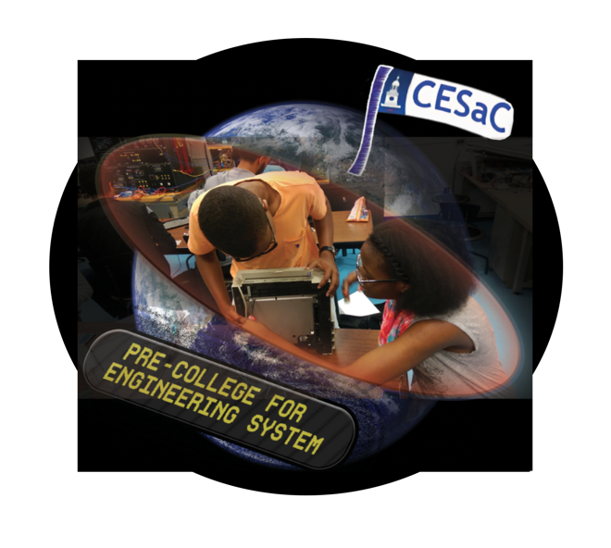

PURPOSE
- To introduce pre-college minority students to research in power industry using modern state-of-the-art technology in applications, Energy Revolution, Nanotechnology and Wireless Communication.
- To involve minority students in developing core competency with Engineering and Science.
- To generate an interest in career options in Engineering Systems.
- To give minority students an opportunity to experience problem solving in a research/project-based teamwork environment consisting of faculty, senior research associates, graduate and undergraduate students.

PROGRAM DETAILS
Students having a strong Mathematics and Science background are selected to live on the campus of Howard University, attend workshops, conduct research, take field trips, and participate in cultural and recreational activities. Rooms and meals are provided, along with a great hourly rate.

MENTOR QUALIFICATIONS
Must be a current college graduate or higher-level undergraduate student. Must have at least a 3.0. Must exude strong academics in the areas of Science and Math.

APPLICATION PROCEDURES
To apply, (i) please complete enclosed application, include official transcript, two letters of recommendation; and (ii) mail your completed application package to:

PCES Summer Outreach Program
Center for Energy Systems and Control (CESaC)
Howard University
2300 6th Street, NW, Suite 1105
Washington, DC 20059

Application Deadline: June 15, 2019
Email application to: cesachoward1@gmail.com

The Pre-College for Engineering Systems (PCES) Mentor Application
Center for Energy Systems and Controls (CESaC)
College of Engineering, Architecture (CEA)
Howard University, Washington DC
June 23 - July 20, 2019

- PERSONAL INFORMATION
Name ________________________________________ Phone No. _______________
FIRST NAME MI LAST NAME

Address ________________________________________________________________

Social Security No.___________________________ US Citizen? Yes _____No ______

If no, type of Visa ________________________________________________________

Ethnic Origin: Black/African American ____ African _____ Hispanic _____ Other _____

Date of Birth _______________ Email: _______________________________________

MM / DD / YY

- EDUCATIONAL INFORMATION
School Name: _______________________________ Phone No.: __________________

School Address: __________________________________________________________
________________________________________________________________________

Major: ____________________________________ Classification: _________________

Expected Graduation Date: ____________

3. List briefly your program-related experience (e.g. courses, work experience, language etc).
_____________________________________________________________________

4. List your extra-curricular activities (e.g. sports, clubs, team, hobbies etc)
_____________________________________________________________________

_____________________________________________________________________

5. WRITTEN ESSAY

- Briefly explain your reasons for participating in the PCES Summer Outreach Program.

6. Attach your resume.

Email application to: cesachoward1@gmail.com

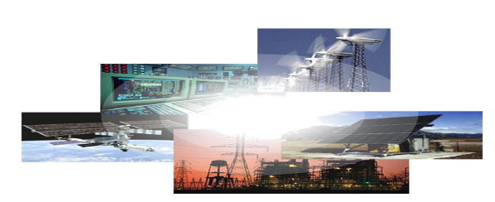

Application Package to be mailed includes:

- Application Form
- Two (2) Professor Recommendation Forms
- Resume
- Essay

Email application to: cesachoward1@gmail.com

Mailing Address:
Howard University Residential Pre-College STEM Program for Engineering Systems
Center for Energy Systems and Control (CESaC)
Howard University
2300 6th Street, NW, Suite 1105
Washington, DC 20059

Application Deadline: June 15, 2019

Email application to : cesachoward1@gmail.com

For more information, please call us at (202) 806-5350 or
email us at cesachoward1@gmail.com

Professor Recommendation Form

Student’s Name: ……………………………………………………………………
Last First M.I.

Professor Name: …...……………………… Professor Phone Number: ………………

Professor Email:……………………………..

Please evaluate the applicant listed above by completing the following information.
Ranking Scale:
(5) – Exceptionally High (4) – Above Average (3) – Average
(2) – Below Average (1) - Poor (0) – No Basis for Evaluation

ABILITY AND PERSONALITY TRAITS 5 4 3 2 1 0

1. Personal Integrity
2. Social and Emotional
3. Ability to work with Peers
4. Ability to work with Teachers
5. Leadership Qualities
6. Oral Communication Skills
7. Analytical Skills
8. Writing Skills
9. Promise of Academic Growth
10. Creativity

Indicate strength of your overall endorsement by checking the appropriate option.
_____Not Recommend _____Recommend with Reservation
_____Recommend _____Highly Recommend

Professor Recommendation Form

Student’s Name: ……………………………………………………………………
Last First M.I.

Professor Name: …...……………………… Professor Phone Number:………………

Professor Email:……………………………..

Please evaluate the applicant listed above by completing the following information.
Ranking Scale:
(5) – Exceptionally High (4) – Above Average (3) – Average
(2) – Below Average (1) - Poor (0) – No Basis for Evaluation

ABILITY AND PERSONALITY TRAITS 5 4 3 2 1 0

1. Personal Integrity
2. Social and Emotional
3. Ability to work with Peers
4. Ability to work with Teachers
5. Leadership Qualities
6. Oral Communication Skills
7. Analytical Skills
8. Writing Skills
9. Promise of Academic Growth
10. Creativity

Indicate strength of your overall endorsement by checking the appropriate option.
_____Not Recommend _____Recommend with Reservation
_____Recommend _____Highly Recommend

Howard University Residential Pre-College STEM Program for Engineering Systems
Outreach Program Outline

1. Introduction to Engineering disciplines, ethics, time management, and professional requirements

2. Electrical engineering foundations involving:
- Ohm’s Law,
- Kirchhoff’s Laws,
- Method of network analysis and applications,
- Control systems and other applications

3. Hands on exercises, introduction to MATLAB, computing software, and program tools, and use of Internet for Problem Solving.

4. Tinkering and understanding of basic principles and operations of simple electrical appliances and consumer electronics.

5. Introduction to Electrical Engineering labs for verification of fundamental laws of Ohm’s and Kirchhoff’s and also diode operations.

6. Nanotechnology, MEMS and wireless communication.

7. Special topic: Entrepreneurship, E-Commerce.

8. Energy Systems (i.e. Photovoltaic, Windmill, Power Systems, etc), Smart Grid and Microgrid Fundamentals and Storage.

9. General Science and Mathematics
- Introduction to Mechanics,
- Pre-Calculus,
- Basic Applications of Mechanics and,
- Probability and Statistics

10. Study of artificial intelligence concepts including:
- Fuzzy logic,
- Expert systems and
- Artificial Neural Networks

11. SAT Preparation

12. Project Design: This will involve design of several projects using principles of Electrical and Computer Engineering and applications of Artificial Neural Nanotechnology, Fuzzy Logic, Expert and Control Systems, Risk Assessment, Public Perception and Decision Support Tools.

13. Mini- and Major project presentations during the closing of the program.

Email application to : cesachoward1@gmail.com

